Week | Assignment | Using  Kit # | Forms due | Reports  due
1 | - | - | - | -
2 | 1B | 1 | C14, C16, C18, C20 | -
3 | 2A | 2 | C16, C18, C20, C25, C27, C29 | R1, R2
4 | 2B | 3 | C16, C18, C20, C25, C27, C29 | R3

Physical & Logical LOC Results

Program 1B
org.greg.drexel.b1.Main.java
- Physical LOC: 109
- Logical LOC: 32

org.greg.drexel.b1.gui.MainFrame.java
- Physical LOC: 296
- Logical LOC: 90

org.greg.drexel.b1.types.FileModeType.java
- Physical LOC: 32
- Logical LOC: 10

org.greg.drexel.b1.io.MyFileReader.java
- Physical LOC: 65
- Logical LOC: 13

org.greg.drexel.b1.io.MyFileWriter.java
- Physical LOC: 64
- Logical LOC: 12

Program 2A
org.greg.drexel.a2.loc.CountingStandard.java (Added from 1B)
- Physical LOC: 109
- Logical LOC: 33 (All 33 LOC added)

org.greg.drexel.a2.loc.LOCCounter.java (Added from 1B)
- Physical LOC: 87
- Logical LOC: 20 (All 20 LOC added)

org.greg.drexel.b1.Main.java (Modified from 1B)
- Physical LOC: 108
- Logical LOC: 41 (1B: 32, so 41-32 = 9 LOC added)

org.greg.drexel.b1.gui.MainFrame.java (Modified from 1B)
- Physical LOC: 174
- Logical LOC: 55 (1B: 90, so 90-55 = 35 LOC deleted)

org.greg.drexel.b1.io.MyFileReader.java (Untouched from 1B)
- Physical LOC: 65
- Logical LOC: 13 (Same LOC from 1B, untouched code)

org.greg.drexel.b1.io.MyFileWriter.java (Modified from 1B)
- Physical LOC: 64
- Logical LOC: 12 (Same LOC from 1B, only modified LOC)

Note: Completely removed org.greg.drexel.b1.types.FileModeType.java from 1B (10 LOC deleted)

Program 2B
org.greg.drexel.b1.Main.java (Modified from 1B)
- Physical LOC: 147
- Logical LOC: 46 (1B: 32, so 46-32 = 14 LOC added)

org.greg.drexel.b1.gui.MainFrame.java (Modified from 1B)
- Physical LOC: 478
- Logical LOC: 148 (1B: 90, so 148-90 = 58 LOC added)

org.greg.drexel.b1.io.MyFileReader.java (Untouched from 1B)
- Physical LOC: 65
- Logical LOC: 13 (Same LOC from 1B, untouched code)

org.greg.drexel.b1.io.MyFileWriter.java (Modified from 1B)
- Physical LOC: 64
- Logical LOC: 11 (1B: 12, so 12-11 = 1 LOC deleted)

org.greg.drexel.b1.types.FileModeType.java
- Physical LOC: 33
- Logical LOC: 11 (1B: 12, 1 LOC added)

org.greg.drexel.b1.types.FileModifyType.java (New in 2B)
- Physical LOC: 35
- Logical LOC: 13 (All 13 lines added, new class)

Totals
Program 1B
- Physical LOC: 626
- Logical LOC: 157
Program 2A
- Physical LOC: 607
- Logical LOC: 174
Program 2B
- Physical LOC: 822
- Logical LOC: 242

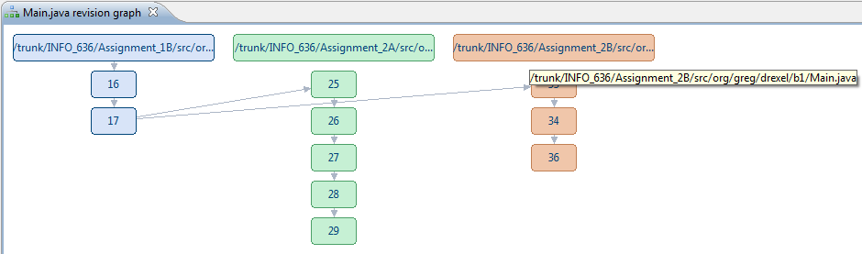
Note: Assignment 1B was SVN merged into Assignment 2B.
Aside: Assignment 1B was also the base for Assignment 2A.
Program 2B Screenshots
Screenshots during testing

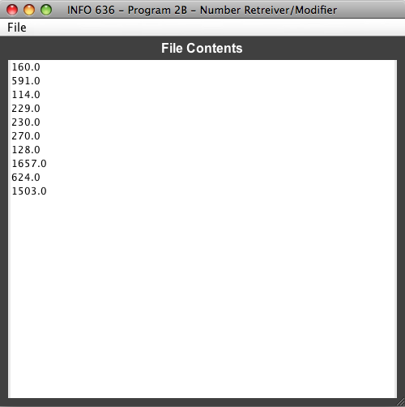
Figure 1. Added all of the numbers from Table D5, Column A

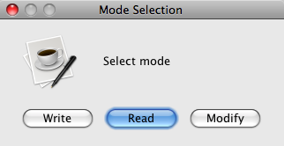
Figure 2. The file from Figure 1 is opened in Modify mode

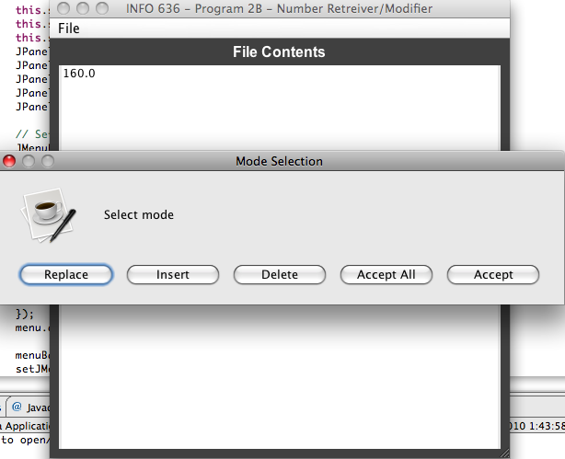
Figure 3. The first line of the file is displayed with a prompt, replace is selected for each entry

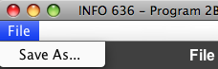
Figure 4. The “Save As…” menu option

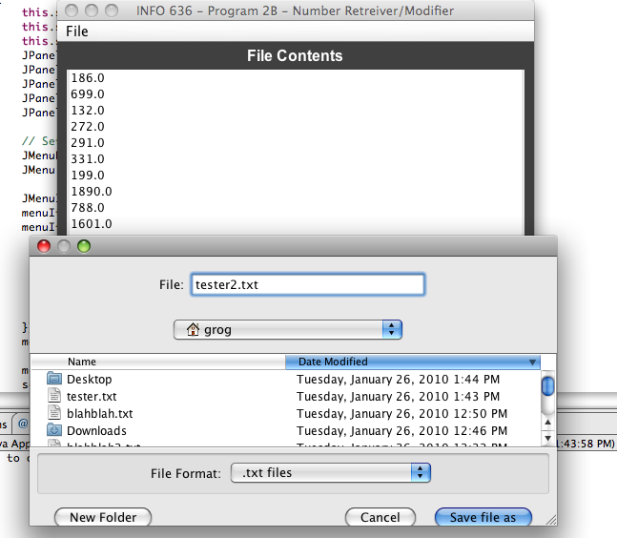
Figure 5. Column B of Table D5 is replaced and saved

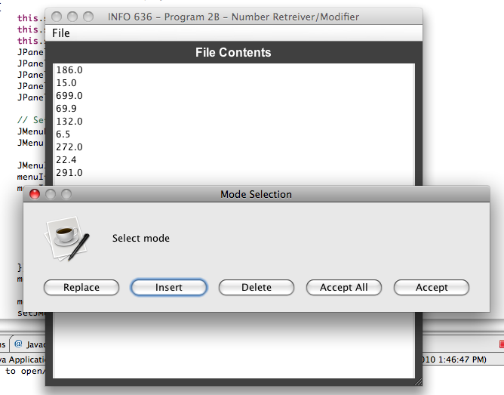
Figure 6. The Insert button is used to add Column C numbers in between each Column B number

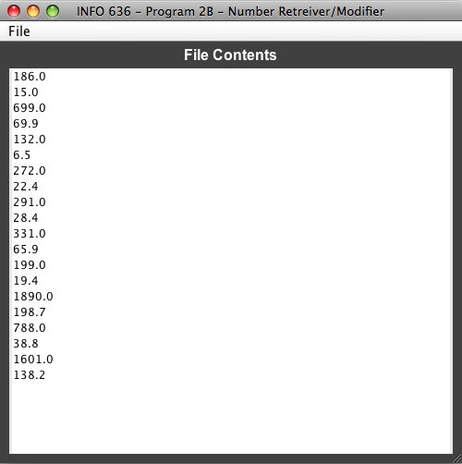
Figure 7. All Column C numbers have been inserted

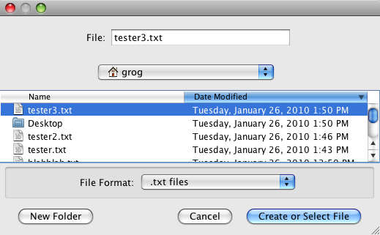
Figure 8. The output from Figure 7 is saved as tester3.txt

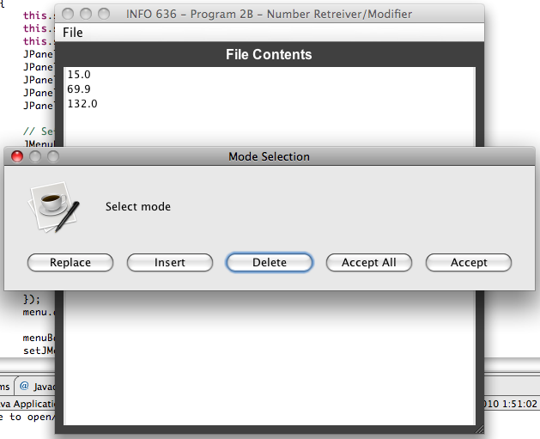
Figure 9. Each item from Column B is removed, leaving only Column C items
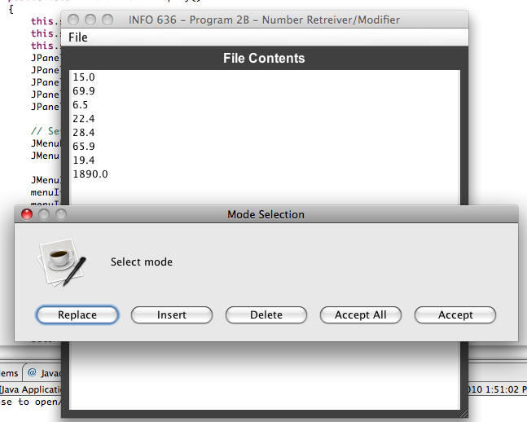
Figure 10. Continuing to remove Column B items

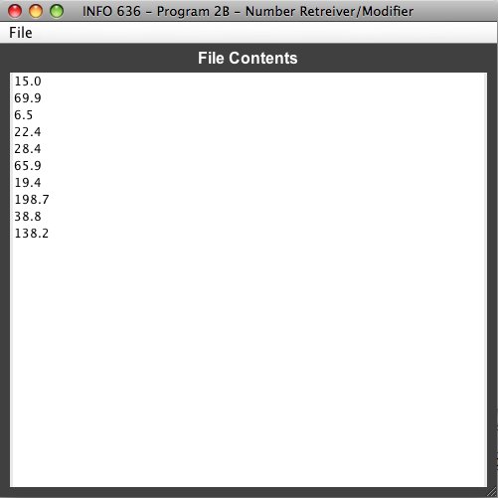
Figure 11. Deletion complete, only Column C items remain

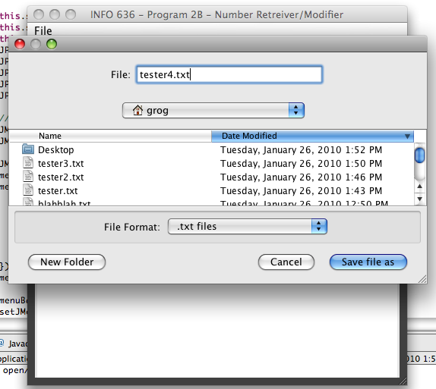
Figure 12. Final file with Column C items is saved as tester4.txt

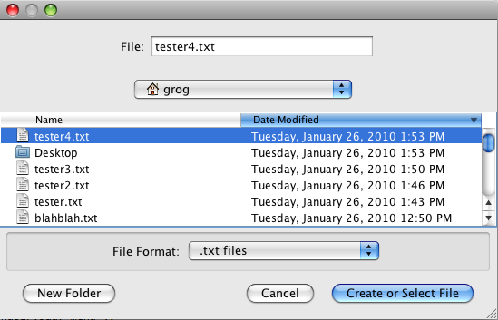
Figure 13. Program ran again, selecting tester4.txt

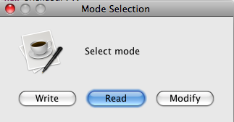
Figure 14. Read mode for tester4.txt selected

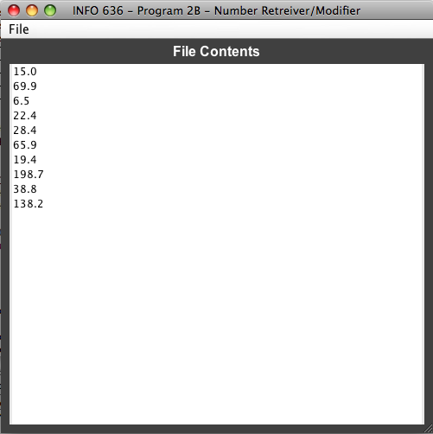
Figure 15. Verification that the file containing only Column C items from Table D5

Report R3

Table D20
Program Number | New and Changed Logical LOC | Number of Defects | Defects/KLOC
1B | 157 (.157 KLOC) | 5 | 31.85
2A | 92 (.092 KLOC) | 4 | 43.48
2B | 81 (.081 KLOC) | 3 | 37.04
Totals | 330 | 12 | 112.37  AVG = 37.46
It appears that the amount of reuse code that I put into assignment 1B has paid off in terms of defects. The number of defects in program 1B are larger than the other two assignments. Defects in the last two assignments can most likely be attributed to more complex code. Because program 2A was unlike 1B or 2B, it had a higher defect rate. Program 2A had a little different goal (counting LOC) than assignment 1B/2B, this caused me to have to change my mindset and could have cause a slightly higher defect/KLOC ratio.

Table D21
Program Number | New and Changed LOC | Defects found (removed) in code | Defects found (removed) in test | Code defects per KLOC | Test defects per KLOC
1B | .157 KLOC | 1 | 4 | 6.37 | 25.48
2A | .092 KLOC | 3 | 1 | 32.61 | 10.87
2B | .081 KLOC | 0 | 2 | 0 | 24.69
Totals | 0.33 KLOC | 4 | 7 | 38.98  12.99 (AVG) | 61.04  20.35 (AVG)
Most of my defects are being found in the test phase. In industry, this is not a good thing as test usually occurs towards the backend of development leaving little time for defect resolution. The other negative to defects found in test, is that more defects can be injected when attempting to apply a fix and in the test phase, this is not a good time to be injecting more defects. I think the code and test defects per KLOC ratio is fairly normal. Most developers won't catch their errors until their software is handed over to be tested. If I paid more attention to what I'm coding, instead of worrying about functionality, I may be able to catch these errors in code before I test them. Although this doesn't matter when you have one tester and one developer and they are the same person (this class), this would be a great creed to follow as a software engineer at work.

Table D22
 | Defects found (removed) in code | Defects found (removed) in testing | Total defects found (removed)
Defects injected in designing | For defects injected in design and found in code:  Total fix time: 3m  Total number of defects: 1  Average fix time: 3m | For defects injected in design and found in test:  Total fix time: 3m  Total number of defects: 1  Average fix time: 3m | For all defects injected in design:  Total fix time: 6  Total number of defects: 2  Average fix time: 3m
Defects injected in coding | For defects injected in code and found in code:  Total fix time: 0  Total number of defects: 0  Average fix time: 0 | For defects injected in code and found in test:  Total fix time: 26m  Total number of defects: 5  Average fix time: 5.2m | For all defects injected in code:  Total fix time: 26m  Total number of defects: 5  Average fix time: 5.2m
Total defects injected | For all defects found (removed) in code:  Total fix time: 24m  Total number of defects: 4  Average fix time: 6m | For all defects found (removed) in test:  Total fix time: 39m  Total number of defects: 7  Average fix time: 5.6m | For all defects:  Total fix time: 68m  Total number of defects: 12*  Average fix time: 5.7m
* Note: I assigned the two defects 1 & 2 from assignment 1B as injected in the planning phase. These were labeled as "N/A" in my original submission. I have been accounting for them as such since the previous assignment, that is why they show up in C25.

Defects found during testing are costing more total time to be fixed, however, the defects removed in code are taking the most average time to repair. This may not be the case in a large scale operation when you factor in the time it takes for a tester to find and error, write an error report, convey that to the developer and have the developer accurately fix the defect (if it is a defect in the first place).

I didn't realize that I was taking so long to fix a defect, but when the time for analysis is factored into the solution, I can see why I average 5.7 minutes to fix any defect. I think this is because not only do I have to determine the cause of the defect, but I have to ensure that the fix I intend to add into the software will actually fix the problem. Defects injected in design take much less time to remove. For me, this was because it was still fresh in my mind, so I usually knew exactly what was wrong. For software companies, the person that does the design is usually never the person doing the software development, so I can see why these defects hurt more when you have more people.
Table C16: Time Recording Log

Student |  | Greg Vannoni |  |  |  |  | Date | 1/24/10
Instructor |  | Glenn Booker |  |  |  |  | Program # | 2B
Date | Start | Stop | Interruption  Time | Delta  Time | Phase | Comments
1/24 | 6:30p | 6:55p | 0 | 25 | PLN | Determined graphical interface changes required to support program 2B
1/25 | 5:10a | 5:15a | 0 | 5 | DESIGN | Determined amount of new code needed to create Accept, Accept All, type of input (lot of reuse from 1B)
1/25 | 5:20p | 6:40p | 10 | 70 | CODE | News break
1/25 | 8:30p | 10:00p | 16 | 74 | CODE | Two phone calls
1/25 | 10:01p | 10:02p | 0 | 1 | COMPILE | No errors
1/25 | 10:03p | 10:10p | 0 | 7 | TEST | GUI modifications complete, buttons added, backend functionality not in place yet
1/26 | 5:00a | 8:10a | 0 | 70 | CODE | Implemented backend functionality for Accept, Accept All, Delete, Replace and Insert
1/26 | 9:15a | 9:25a | 0 | 10 | CODE | Added "Save As..." menu, but not yet implemented
1/26 | 9:26a | 9:27a | 0 | 1 | COMPILE
1/26 | 9:28a | 9:38a | 0 | 10 | CODE | Added "Save As..." functionality
1/26 | 9:39a | 9:40a | 0 | 1 | COMPILE | Compiled successful
1/26 | 9:41a | 9:42a | 0 | 1 | TEST | Found that "Save As..." feature not saving new lines
1/26 | 9:43a | 9:45a | 0 | 2 | CODE | Added newline to setFileContents
1/26 | 9:46a | 9:47a | 0 | 1 | COMPILE
1/26 | 12:30p | 12:50p | 0 | 20 | TEST | Personal testing complete, will do testing outlined in book later.
1/26 | 1:42p | 1:55p | 0 | 13 | TEST | More testing to ensure the program works with the book's test example
1/26 | 1:56p | 2:06p | 0 | 10 | PM | Cleaned up daily log and added some small defects from the last two days into C18
1/28 | 6:10p | 6:35p | 0 | 25 | CODE | Added comments to new code
1/28 | 6:36p | 7:00p | 0 | 24 | PM | Worked on C25 and some of the introduction
1/29 | 6:10a | 6:30a | 0 | 20 | PM | Worked on R3
1/29 | 7:00p | 7:10p | 0 | 10 | PM | Worked more on R3 and
1/30 | 12:00p | 2:40p | 0 | 160 | PM | Worked on C27, added screenshots

Table C18 Defect Recording Log
Defect Types
10 Documentation 60 Checking
20 Syntax 70 Data
30 Build, Package 80 Function
40 Assignment 90 System
50 Interface 100 Environment
Student |  |  |  | Greg Vannoni |  |  |  |  |  |  |  | Date |  | 1/25/10
Instructor |  |  |  | Glenn Booker |  |  |  |  |  |  |  | Program # |  | 2B
Date |  | Number |  |  |  | Type |  | Inject |  | Remove |  |  | Fix Time |  | Fix Defect
1/25 |  | 1 |  |  |  | 80 |  | Planning |  | Design |  |  | 5
Description: |  |  | Had to rethink the idea of removing one of the numbers when the user presses the “delete” button. Current logic would remove the next number and not the current number.
Date |  | Number |  |  |  | Type |  | Inject |  | Remove |  |  | Fix Time |  | Fix Defect
1/26 |  | 2 |  |  |  | 40 |  | Code |  | Test |  |  | 7
Description: |  |  | Needed to use .clone() to duplicate an arraylist instead of assigning finalOutput to fileContents in the initializeAndDisplayWithPrompt() method.
I was performing data manipulation on the fileContents ArrayList and I shouldn’t have been.
Update: Ended up not using this .clone()/ArrayList at all.
Date |  | Number |  |  |  | Type |  | Inject |  | Remove |  |  | Fix Time |  | Fix Defect
1/26 |  | 3 |  |  |  | 70 |  | Code |  | Test |  |  | 2
Description: |  |  | Because I was working from with ArrayList<Double> in the setFileContents method
in 1B, where a user could supply an ArrayList of Doubles, but then switch to ArrayList<String> in 2B,
I forgot to add a newline character, so each time I saved a file, there were no newlines after each line.
Date |  | Number |  |  |  | Type |  | Inject |  | Remove |  |  | Fix Time |  | Fix Defect
Description:
Date |  | Number |  |  |  | Type |  | Inject |  | Remove |  |  | Fix Time |  | Fix Defect
Description:
Date |  | Number |  |  |  | Type |  | Inject |  | Remove |  |  | Fix Time |  | Fix Defect
Description:
Date |  | Number |  |  |  | Type |  | Inject |  | Remove |  |  | Fix Time |  | Fix Defect
Description:

Table C25 PSP0.1 Project Plan Summary

Student | Greg Vannoni | Date | 1/28/10
Program |  | Program # | 2B
Instructor | Glenn Booker | Language | Java

Program Size (LOC) | Plan |  |  |  | Actual |  |  |  | To Date
Base(B) |  |  |  |  | 157
 |  |  |  |  | (Measured)
Deleted (D) |  |  |  |  | 1
 |  |  |  |  | (Counted)
Modified (M) |  |  |  |  | 15
 |  |  |  |  | (Counted)
Added (A) |  |  |  |  | 242-157+1-30 = 56
 |  |  |  |  | (T-B+D-R)
Reused (R) |  |  |  |  | 30 |  |  |  | 20
 |  |  |  |  | (Counted)
Total New & Changed (N) | 70 |  |  |  | 66+15 = 81 |  |  |  | 193
 |  |  |  |  | (A+M)
Total LOC (T) |  |  |  |  | 242 |  |  |  | 416
 |  |  |  |  | (Measured)
Total New Reused Reusable |  |  |  |  | 20 |  |  |  | 70
Time in Phase (min.) | Plan |  | Actual |  |  |  | To Date |  |  |  | To Date %
Planning | 10 |  | 25 |  |  |  | 36 |  |  |  | 3.11%
Design | 10 |  | 5 |  |  |  | 51 |  |  |  | 4.43%
Code | 150 |  | 261 |  |  |  | 540 |  |  |  | 46.88%
Compile | 3 |  | 4 |  |  |  | 7 |  |  |  | 0.61%
Test | 40 |  | 41 |  |  |  | 104 |  |  |  | 9.03%
Postmortem | 100 |  | 224 |  |  |  | 414 |  |  |  | 35.94%
Total | 313 |  | 560 |  |  |  | 1152 |  |  |  | 100%
Defects Injected |  |  | Actual |  |  |  | To Date |  |  |  | To Date %
Planning |  |  | 1 |  |  |  | 5 |  |  |  | 41.66%
Design |  |  | 0 |  |  |  | 2 |  |  |  | 16.66%
Code |  |  | 2 |  |  |  | 5 |  |  |  | 41.66%
Compile |  |  | 0 |  |  |  | 0 |  |  |  | 0
Test |  |  | 0 |  |  |  | 0 |  |  |  | 0
Total Development |  |  | 3 |  |  |  | 12 |  |  |  | 100%
Defects Removed |  |  | Actual |  |  |  | To Date |  |  |  | To Date %
Planning |  |  | 0 |  |  |  | 0 |  |  |  | 0
Design |  |  | 1 |  |  |  | 1 |  |  |  | 8.33%
Code |  |  | 0 |  |  |  | 4 |  |  |  | 33.33%
Compile |  |  | 0 |  |  |  | 0 |  |  |  | 0
Test |  |  | 2 |  |  |  | 7 |  |  |  | 58.33%
Total Development |  |  | 3 |  |  |  | 12 |  |  |  | 100%
After Development |  |  | 0 |  |  |  | 0

Table C27 Process Improvement Proposal (PIP)

Student | Greg Vannoni |  | Date | 1/30/10
Instructor | Glenn Booker |  | Program # | 2B
Process | PSP0.1 | Elements

PIP Number
 |  | Problem Description:
1 |  | Removing more defects during testing than coding. This means that
 |  | I'm not catching defects before I test.
2 |  | I can't access my documents when I'm traveling (like I did most of this week). I started some of this documentation on my PC, but had my laptop
 |  | for most of the week to perform coding.
PROPOSAL
PIP # |  | Proposal Description
1 |  | I will spend more time when I develop code so I can catch silly mistakes
 |  | before I start testing. In a corporate, these defects found in test are much
 |  | more expensive than they are in this class.
2 |  | Add the documents to my Google code site, so I can use SVN to access
 |  | both my code and my documents for this class so I don't have to merge
 |  | everything together when I get back from travel.
Notes and Comments:
 |  | This assignment had more logic and thinking involved than previous ones.
 |  | I was able to leverage off my design from Program 1B which allow for
 |  | much more code reuse which produced a stable product a little faster.

